

National University of Computer and Emerging Sciences

Blockchain and Cryptocurrency Project

Project Title: Crowdfunding Platform

Group Members:

1. Mansoor Tariq 20L-1369

2. Sana Ahmed 20L-1376

3. Waiza Zainab 20L-1253

**Table of Contents**

Abstract 4

Introduction 5

Objectives 5

1. Decentralization of Crowdfunding: 5

2. Transparent and Trustworthy Contributions: 5

3. Smart Contract Automation: 5

4. Inclusive and Permissionless Participation: 6

Goals and Scope 6

Goals: 6

1. Revolutionizing Fundraising Dynamics: 6

2. Enhancing Transparency: 6

3. Automating Crowdfunding Processes: 7

4. Promoting Inclusivity: 7

Scope: 7

1. Decentralized Ecosystem: 7

2. Transparency in Transactions: 7

3. Smart Contract Automation: 7

4. User-Friendly Interface: 7

5. Inclusive Participation Model: 8

Technology Stack 8

Features 8

1) Start Campaign: 8

2) Contribute to Campaign: 10

3) Withdrawal of Funds 10

4) Get all Contributors. 11

Conclusion 12

# Table of Figures

Figure 1: Starting a Campaign 9

Figure 2: Campaign Successfully Started 9

Figure 3: Contributing to a Campaign 10

Figure 4: Requesting for Withdraw of Funds 10

Figure 5: Withdrawal Requests 11

Figure 6: Vote for Approval 11

Figure 7: All Contributors of Campaign 11

# Abstract

Crowdfunding-DAPP is a cutting-edge decentralized application designed to reshape the crowdfunding landscape by harnessing blockchain technology's transformative potential. Rooted in decentralization, transparency, and inclusivity principles, this project introduces a novel approach to fundraising. The integration of MetaMask, a leading Ethereum wallet, enhances the user experience by providing a secure and seamless transaction environment. In response to challenges faced by traditional crowdfunding platforms, the Crowdfunding-DAPP leverages blockchain to establish a decentralized ecosystem, eliminating intermediaries and fostering peer-to-peer interactions. MetaMask integration further enhances transparency and trust, allowing users real-time visibility into contributions and campaign progress. Smart contract automation, coupled with MetaMask capabilities, ensures streamlined project completion and fund withdrawals, providing security and efficiency in the crowdfunding process. This project represents a significant advancement in crowdfunding, offering a user-friendly, secure, and transparent platform that empowers project owners and contributors. The detailed documentation provides insights into the architecture, MetaMask integration, implementation details, and usage guidelines, offering a comprehensive resource for developers, contributors, and enthusiasts alike. The Crowdfunding-DAPP, with its forward-thinking design and MetaMask integration, stands as a testament to the potential of decentralized technologies in revolutionizing fundraising.

# Introduction

Crowdfunding-DAPP is an innovative decentralized application designed to revolutionize traditional crowdfunding methods by integrating blockchain technology. This project addresses inherent challenges in existing crowdfunding platforms by prioritizing decentralization, transparency, and inclusivity. MetaMask, a prominent Ethereum wallet, is seamlessly integrated to enhance transaction security and streamline user interactions. In this introduction, we outline the project's key objectives, the significance of MetaMask integration, and its potential impact on reshaping the crowdfunding landscape.

# Objectives

Well-defined objectives drive the Crowdfunding-DAPP project to transform the conventional crowdfunding paradigm. These objectives are meticulously crafted to address the limitations of existing platforms and introduce a more decentralized, transparent, and inclusive approach to fundraising.

## 1. Decentralization of Crowdfunding:

Establish a decentralized crowdfunding ecosystem, eliminating reliance on centralized intermediaries. Traditional crowdfunding platforms often introduce opacity and dependency on intermediaries, hindering the trust between project owners and contributors. The objective is to create a peer-to-peer network facilitated by blockchain technology, ensuring transparency and autonomy in all interactions.

## 2. Transparent and Trustworthy Contributions:

Provide contributors with real-time visibility into their contributions and the progress of crowdfunding campaigns. Transparency is a cornerstone in building trust within crowdfunding. By leveraging blockchain's transparency and integrating MetaMask for secure transactions, contributors gain confidence in utilizing their funds and the overall success of campaigns.

## 3. Smart Contract Automation:

Implement smart contracts to automate critical processes, including project completion, expiration, and fund withdrawals. Smart contracts, written in Solidity, introduce self-executing code that automates key aspects of crowdfunding campaigns. This not only streamlines the process but also ensures the reliability and security of transactions. MetaMask seamlessly interacts with these contracts, providing contributors and project owners with a secure environment.

## 4. Inclusive and Permissionless Participation:

Enable universal participation in crowdfunding campaigns without the need for formal user registration. Blockchain's permissionless nature and MetaMask integration allow individuals to participate in crowdfunding without cumbersome registration processes. This inclusivity promotes a broader and more diverse engagement with fundraising campaigns.

# Goals and Scope

The Crowdfunding-DAPP project is propelled by a set of overarching goals that collectively redefine the landscape of fundraising platforms. These goals are carefully crafted to address existing challenges in traditional crowdfunding models, aiming to introduce a platform that is not only decentralized and transparent but also inclusive and user-friendly.

## Goals:

### 1. Revolutionizing Fundraising Dynamics:

The primary goal is to revolutionize how fundraising is conducted by eliminating the reliance on centralized intermediaries. The project envisions a decentralized ecosystem where contributors and project owners interact directly, fostering trust, transparency, and autonomy in fundraising transactions.

### 2. Enhancing Transparency:

A central goal is to give contributors real-time visibility into their contributions and the progress of crowdfunding campaigns. Transparency is a cornerstone in building trust within the crowdfunding community, addressing concerns about using funds and overall campaign success.

### 3. Automating Crowdfunding Processes:

The project aims to leverage the power of smart contracts to automate critical processes, including project completion, expiration, and fund withdrawals. This automation streamlines the crowdfunding process and introduces a new level of reliability and security to transactions.

### 4. Promoting Inclusivity:

Inclusivity is a crucial goal to enable universal participation in crowdfunding campaigns. The project aims to eliminate the need for formal user registration, embracing blockchain's permissionless nature. This inclusivity opens up crowdfunding opportunities to a broader and more diverse audience.

## Scope:

### 1. Decentralized Ecosystem:

The scope of the Crowdfunding-DAPP extends to establishing a decentralized ecosystem that fosters peer-to-peer interactions. This encompasses the elimination of intermediaries, creating a platform where contributors and project owners engage directly.

### 2. Transparency in Transactions:

The project includes implementing mechanisms to ensure transparency in all transactions. Contributors will have real-time access to information regarding their contributions, providing a transparent and trustworthy environment.

### 3. Smart Contract Automation:

The project's scope extends to integrating smart contracts for automating key crowdfunding processes. Smart contracts, written in Solidity, will govern project completion, expiration, and fund withdrawals, enhancing efficiency and security.

### 4. User-Friendly Interface:

A user-friendly interface is within the project's scope, ensuring that contributors and project owners can seamlessly navigate the platform. Integration with MetaMask further enhances the user experience, providing a secure and accessible environment.

### 5. Inclusive Participation Model:

The project aims to broaden the participation base by eliminating the need for formal user registration. The scope includes leveraging blockchain's permissionless nature to enable anyone to participate in crowdfunding campaigns.

# Technology Stack

* Next.js: Frontend development for a dynamic and responsive user interface.
* Solidity: Smart contract language for Ethereum blockchain development.
* Tailwind CSS: Styling and design to enhance the overall user experience.
* Ether.js and Web3.js: Web3 clients for contract testing and frontend integration.
* Chai JavaScript testing framework to ensure the reliability of the codebase.
* Hardhat: Ethereum development environment for testing and deployment.
* Redux: State management to centralize application state.

# Features

## Start Campaign:

Just like Crowdfunding in the real world and on other crowdfunding platforms, anyone can create a campaign in a few minutes. The Ethereum-based smart contract will manage the campaign information and thus cannot be tampered with.

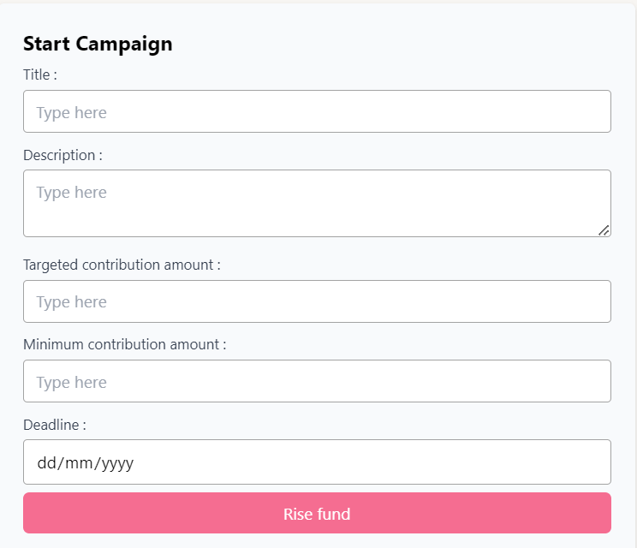

Figure : Starting a Campaign

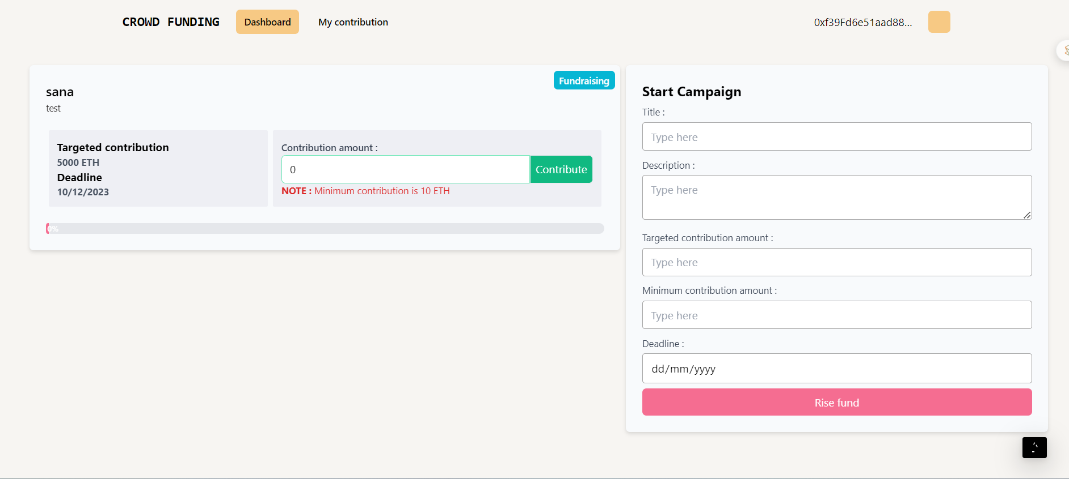

Figure : Campaign Successfully Started

## Contribute to Campaign:

Once a campaign has been created, users can share the campaign, and anybody can contribute to the campaign. The funds will go to the address of the campaign and not to the creator of the campaign, thus making the process more efficient and anti-fraudulent.

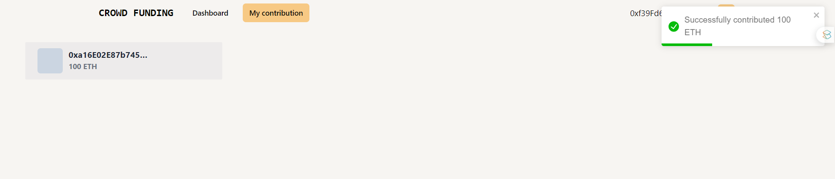

Figure : Contributing to a Campaign

## Withdrawal of Funds

The Creator of a Campaign can propose how to use the funds in the form of a Withdrawal Request. Anybody who contributes more than a particular amount is called an approver and will be able to approve or deny the request.

**Funds can’t be withdrawn without the approval of 50% approvers.**

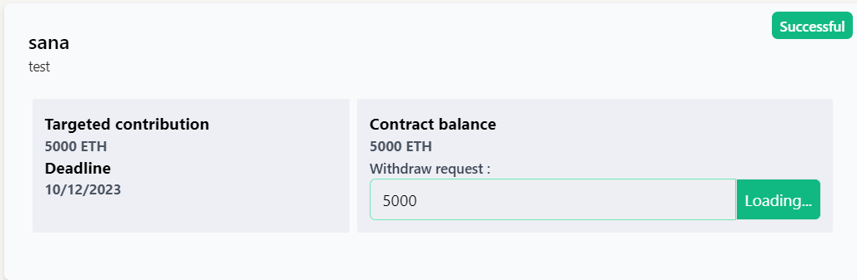

Figure : Requesting for Withdraw of Funds

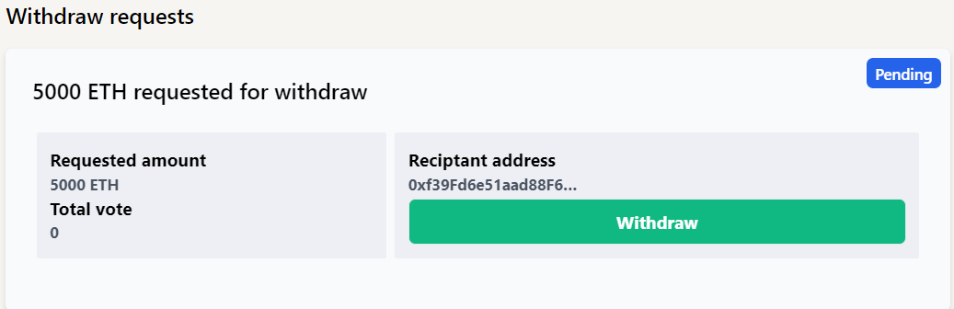

Figure : Withdrawal Requests

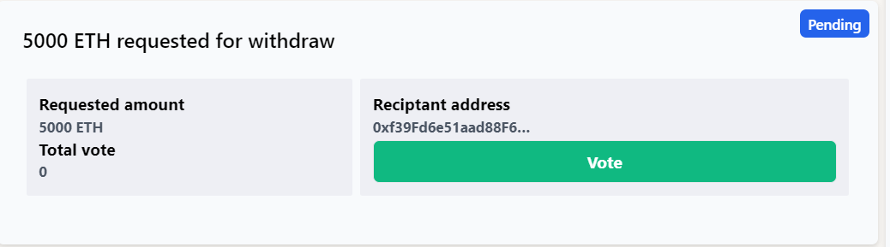

Figure : Vote for Approval

## Get all Contributors.

We can get all the contributors who have contributed to the campaign.

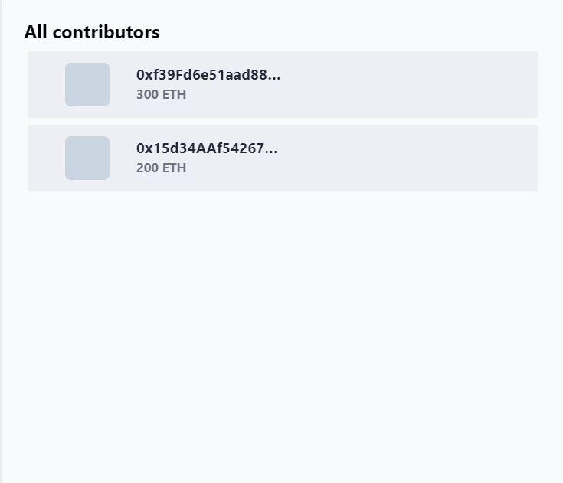

Figure : All Contributors of Campaign

# Conclusion

In conclusion, the Crowdfunding-DAPP project emerges as a pioneering force in reshaping the landscape of fundraising platforms. Through a meticulous alignment of goals and comprehensive scope, this decentralized application stands poised to redefine the dynamics of crowdfunding by leveraging the transformative capabilities of blockchain technology. The project's commitment to decentralization, transparency, and inclusivity aligns with the evolving global community seeking more reliable, trustworthy, and user-centric fundraising experiences. The primary goals, from eliminating centralized intermediaries to fostering inclusivity, collectively contribute to the overarching vision of creating a platform that empowers contributors and project owners. By embracing blockchain's transparency, the project addresses longstanding concerns about accountability and trust within crowdfunding campaigns. Furthermore, the integration of intelligent contract automation and MetaMask enhances the crowdfunding process's efficiency, security, and user-friendliness. The scope of the Crowdfunding-DAPP extends beyond mere technological innovation. It encompasses establishing a decentralized ecosystem that champions peer-to-peer interactions, transparent transactions, and an inclusive participation model. The project's ambitions to eliminate registration barriers and provide a user-friendly interface underscore its commitment to creating a platform accessible to a diverse global audience. As the Crowdfunding-DAPP project embarks on its journey to redefine crowdfunding, the integration of MetaMask is crucial in ensuring secure and seamless transaction interactions. This project holds the potential to revolutionize fundraising practices, providing a trustworthy and transparent environment that aligns with the evolving expectations of contributors and project owners alike. The Crowdfunding-DAPP project represents a significant step towards democratizing fundraising, fostering a community-driven approach emphasizing transparency, inclusivity, and technological innovation. By addressing the limitations of existing crowdfunding platforms, this project endeavors to contribute to a future where fundraising is secure, efficient, and accessible to a global audience.

**Video Link:**

https://drive.google.com/file/d/1HtxFRw5Q8k6U5LAz8_xuF0XjtxVAXZoj/view?usp=sharing